**The Alita Risk Dashboard**

**User manual**

**Jiejun Peng, Tingjue Han, Songyan Zhao and Xinda Chen**

**Johns Hopkins Carey Business School**

**Introduction**

**Getting to know the Alita risk dashboard**

The Alita risk dashboard can give clients an overall visualized view of stock market industry weight, historical volatility, simulated future risk and cross-industry correlation.

**Dashboard features**

* Provides the capability to customize the look of Alitas Risk Dashboard to meet clients’ specific needs and preferences.
* Provides filtering capabilities to limit the data being displayed in the dashboard based upon three specified parameters: industry, time and expected value.
* Provides the capability to show the collected data analysis in various formats( line chart, scatter plot).
* Provide an enhanced capability to display more detailed and focused information.

**Dashboard Guidance**

**Home page**

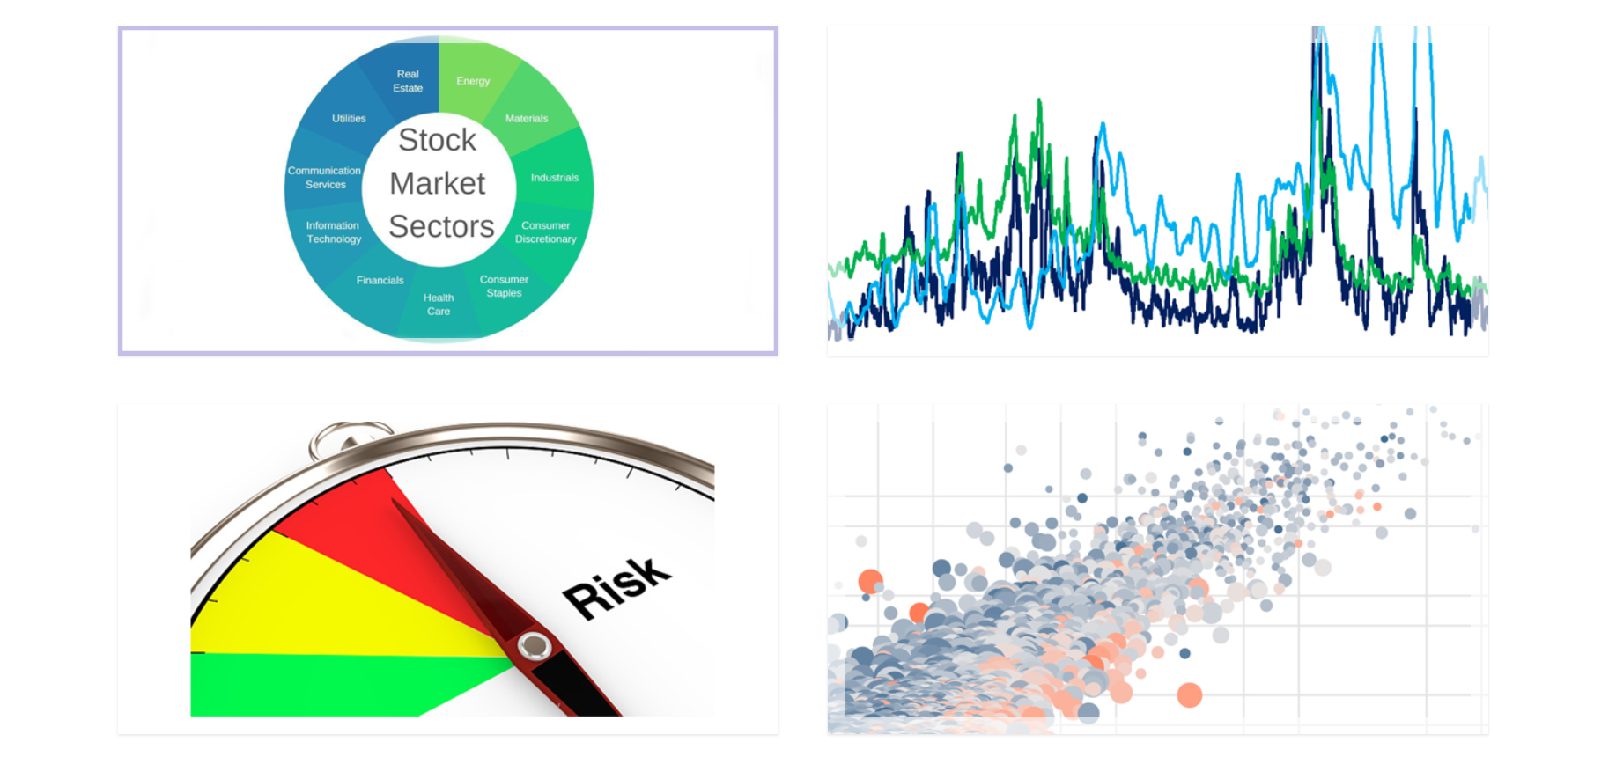

There are 4 parts in the home page including stock market industry weight, single industry volatility, single industry risk, and cross-industry correlation. Users can click on any picture, and then redirect to another specific page.

**Stock market industry weight**

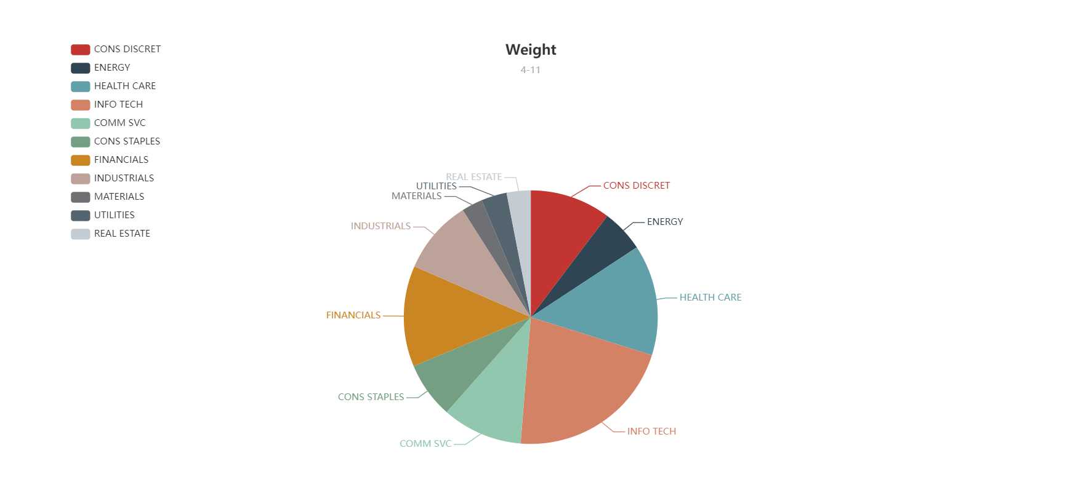

This part provides an overall view of the stock market, it shows the weight of each sector. Move the mouse on the pie chart, it will show users the share of this sector. Users can also click the sector to go to the page that displays the volatility of this sector.

**Historical industry volatility**

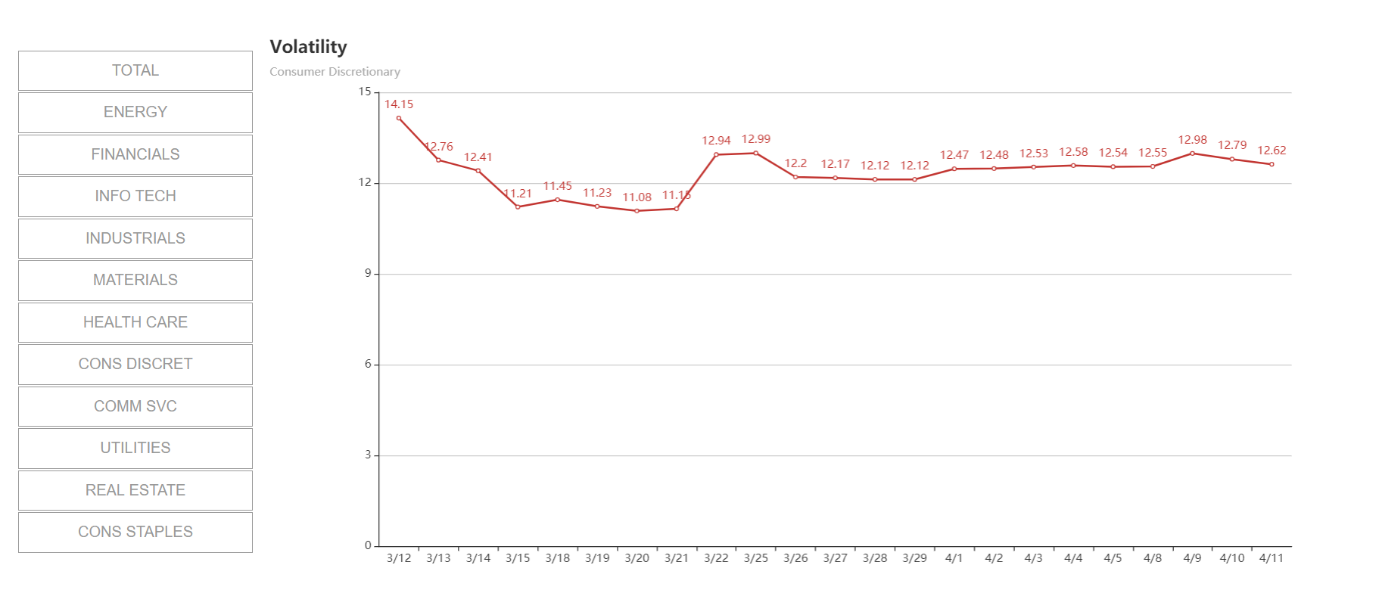

This part shows total and every single industry’s volatility in a month including 11 sectors of the S&P 500 - Energy, Financials, Information technology, Industrials, Materials, Health Care, Consumer Discretionary, Communication Services, Utilities, Real Estate, and Consumer Staples. Users can click on the menu in the left part, and the dashboard would show the related line chart. If users want to go back to the homepage, just click the Johns Hopkins University icon in the top left corner.

**Simulated future industry risk**

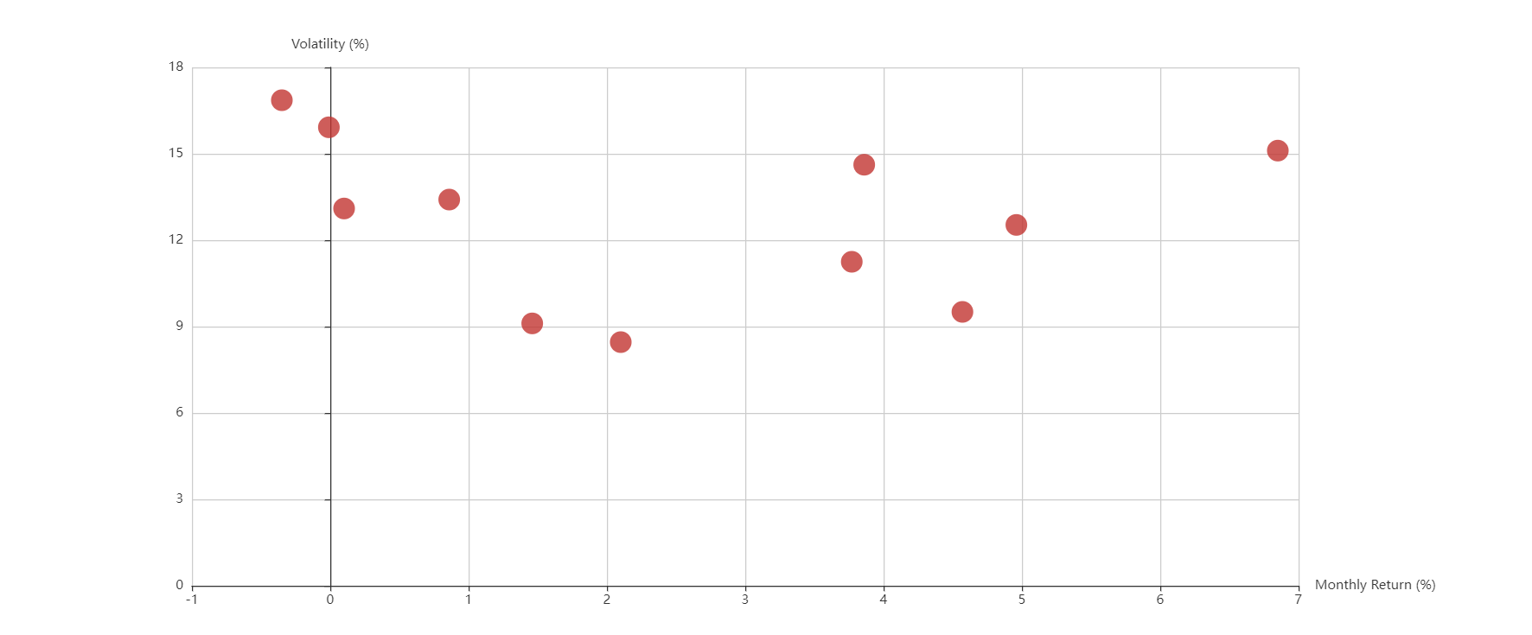

The up part of the risk page shows the relationship between the Monthly Return and Volatility of each sector. From the scatter, users can easily choose the better investment selections which have higher Monthly Return and lower Volatility.

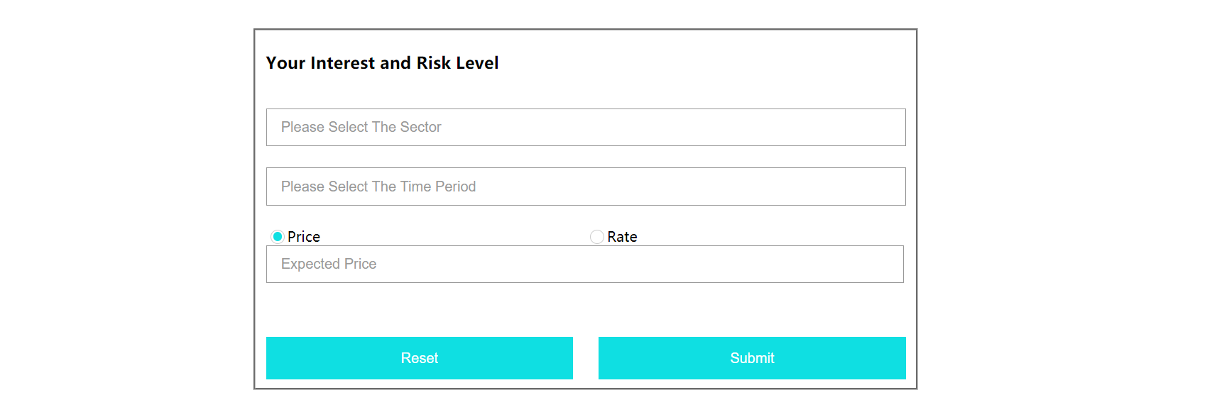

Users can also choose sectors of their own interests at the bottom part in a time period of a week or a month and type in their expected price or rate in this specific period. The “Reset” button enables users to retype in the information in case they make a mistake.

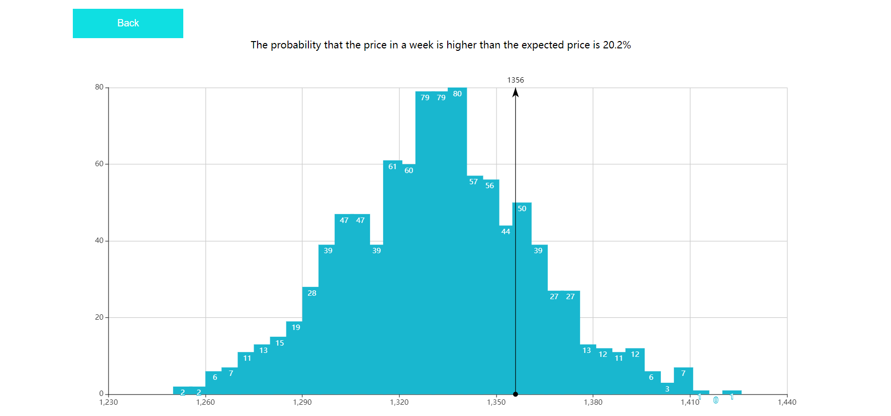

Once they click on the “Submit” button, it will redirect to a new page that shows the distribution of the stock price of the chosen sector in the chosen period based on a 1000-time simulation. The black vertical line is the expected price of the users. The text above the histogram tells the users the probability that the price or rate is higher than their expectation in this period. Users can click on the “Back” button to go back to the former page.

**Cross-industry and cross-index correlation**



There are two sub-parts in this part. Users can click on the “Sectors” button to see the cross-industry correlation chart, and can also click on the “Index” button to find the cross-index correlation chart.

1. **Cross-industry correlation**

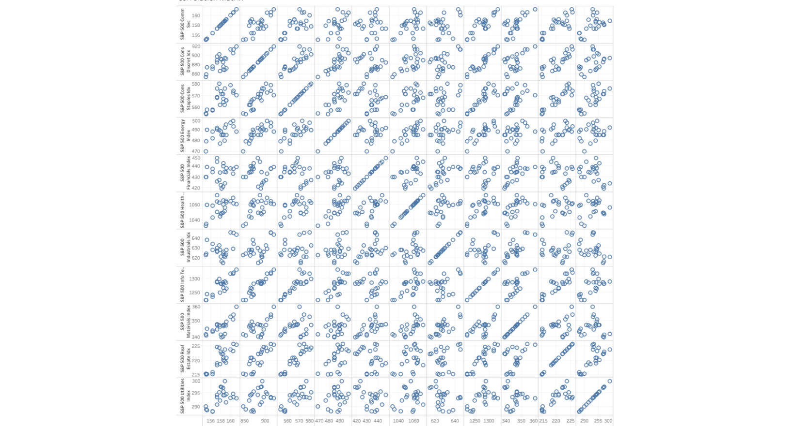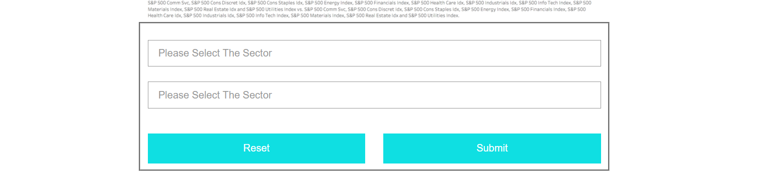

In this page, the upper picture is the summary of the correlation between any two of 11 industries. If users want to go deeper to see the specific one, you can choose two sectors in the below, and then click the “Submit” button to see the big picture you want.

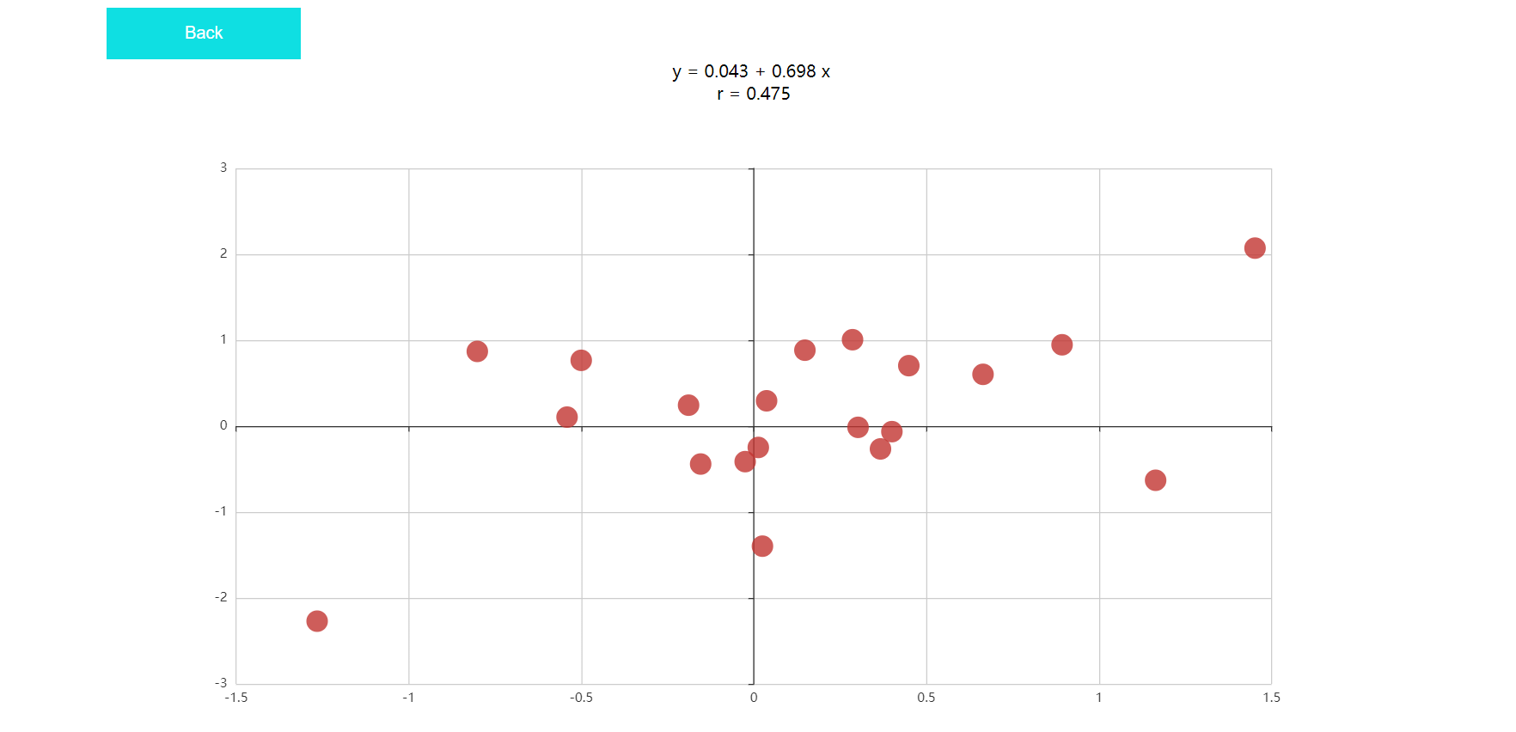

This page shows the specific correlation between the two industries. The upper shows the linear regression results. For this example, “y=0.043+0.0698x” indicates the equation of best-fit line based on linear regression function. “r=0.475” represents the correlation index, if r is higher, the correlation between these two industries is higher. Users can also click on the “Back” button to go back to the previous page.

**(2)cross-index correlation**

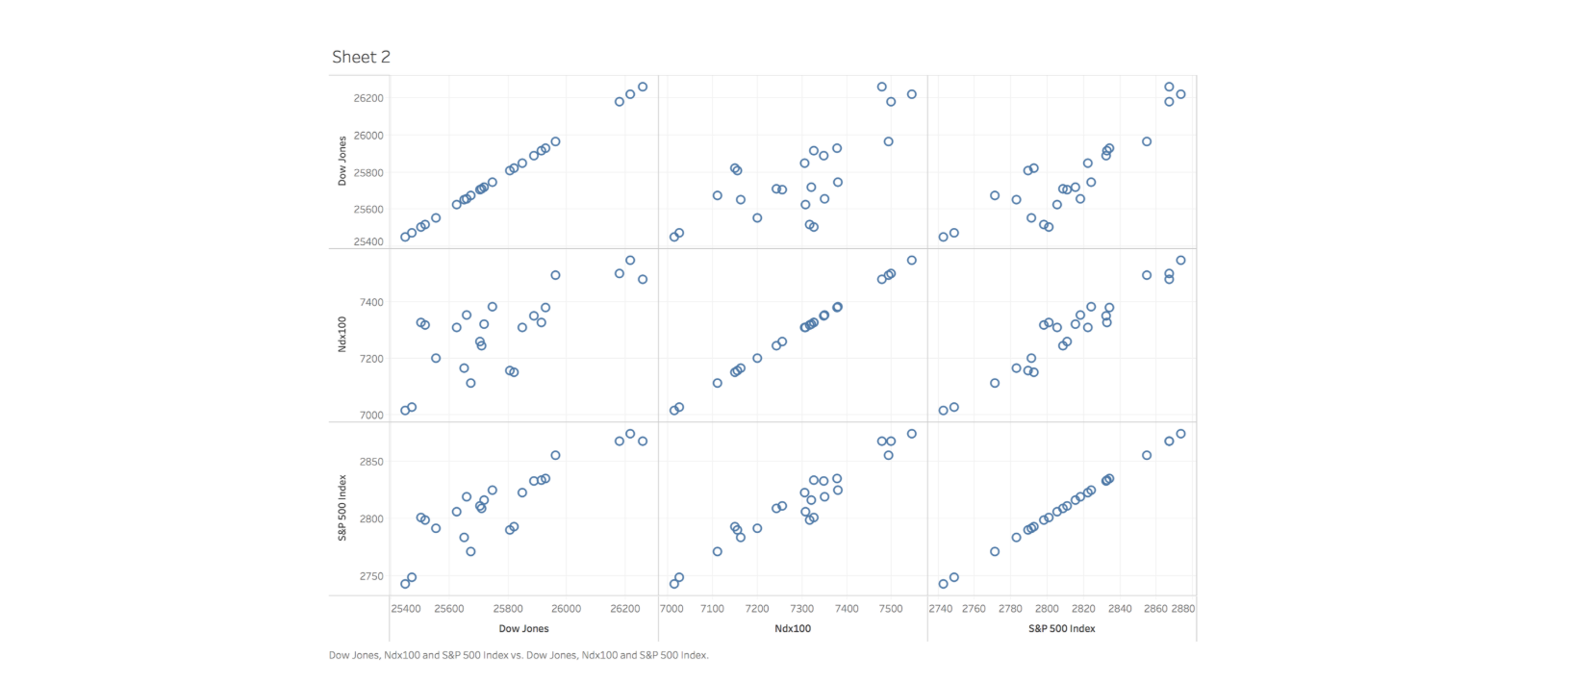

In this page, the upper picture is the summary of the correlation between two indexes. If users want to go deeper to see the specific one, you can choose two indexes in the below, and then click the “Submit” button to see the big picture you want.

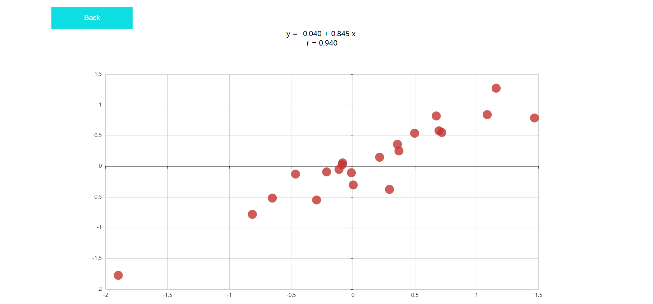

This page shows the specific correlation between two indexed. The upper shows the linear regression results. For this example, “y=0.040+0.845x” indicates the equation of best-fit line based on linear regression function. “r=0.940” represents the correlation index, if r is higher, the correlation between these two indexed is higher. Users can also click on the “Back” button to go back to the previous page.